**Table of Contents**

1 Requirements 2

2 Description and usage 4

2.1 The “Screen” checkbox 4

2.2 The “Snap” checkbox 4

Author: Muresan, Radu Adrian (SMS Metallurgy Romania S.r.l.)

# Requirements

Files to keep in the same folder as the executable:

* **The SQL file of the menu reflecting the current menu on the WinCC client**
* **Magic.dll**
* **PInvoke.Windows.Core.dll**

The remote desktop session to the machine has to be visible as in the picture below (not minimized in the taskbar but also not necessarily maximized).

The remote desktop session to the machine must be configured as in the following figure or a similar position (snapped to a corner of your desktop with smart sizing active) before pressing the “Time!” button:

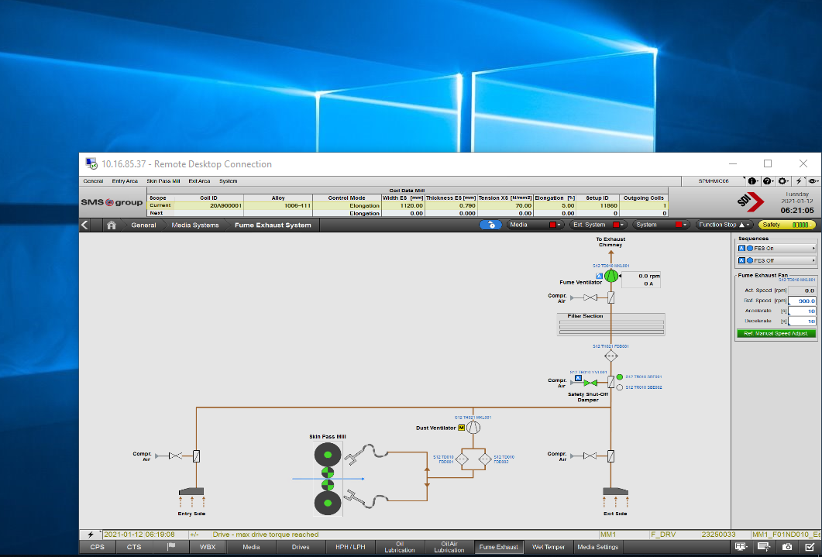

1 Possible desktop configuration for an RDP session for data gathering

# Screens

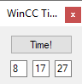

2 Minimized UI (activated/deactivated on double click in the empty area of the UI)

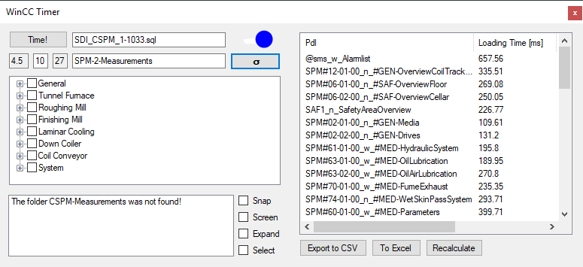

3 The WinCC Timer with expanded calculations

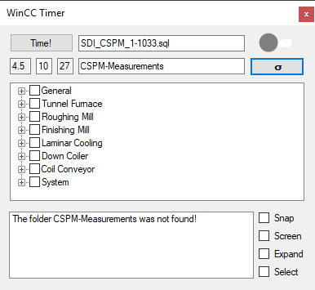

4 UI without calculations pane

# Description and usage

This program’s purpose is to quantify the loading time of WinCC pages.

Every notable UI object has a tooltip to explain its purpose or its connected action.

In order to do this it will require gathering several (I recommend around 10) datasets by the program itself (this process starts on pressing the “Time!” button).

Once you press “Time!” and the RDP is configured as in the figure in ‘Prerequisites’, you have to take your cursor out of the remote session so that you can carry on with other activities. Otherwise your cursor is controlled by the program and it may interfere with the execution.



5 Initial configuration of gathering runs

The above figure shows the configuration of a data gathering run that will run for 8 hours during which 17 full datasets are gathered for a project taking around 27 minutes to analyze.

The only input allowed is the middle input, i.e. the number of runs desired to do. on that input you will get an estimate of how many hours that will take in the text box to its left.

Once the datasets are gathered, the small sigma ( **σ** ) button calculates the average loading times for each individual page collected in the datasets – as shown in the picture, a data table appears on the right side once calculation is finished.

Once calculation is finished, press “Export to CSV” as desired to generate a csv file with the visible data.

## The “Screen” checkbox

Once checked, will take screenshots for every page in the calculations folder.

## The “Snap” checkbox

If this checkbox is checked, the program will take a screenshot after 1.5 seconds after opening the pages, and only for the first run. All “.png” files will be stored in the “Screenshots” folder.